Facebook store front app
- Go to the facebook developer center to create a facebook app
https://developers.facebook.com/
Click “Apps” --> “Create a New App”
“Category” --> choose “App for pages”

After you build the app, then click “Setting”, fill the “App Domains”, it should be the domain you put your code, here I set “secure.compandsave.com”, and this domain should be security http.

Then, we can choose what kind of app, it can be page tab app or canvas page app. Click “Add Platform”, choose “Page Tab”.
“Page Tab Name” --> “Store”
“Page Tab URL” --> “https://secure.compandsave.com/lf/cas_store/index.php”
“Secure Page Tab URL” --> “https://secure.compandsave.com/lf/cas_store/index.php”
Now, it creates a facebook tab app. If you want this app available to general public, in the “Status & Review” click “YES”.
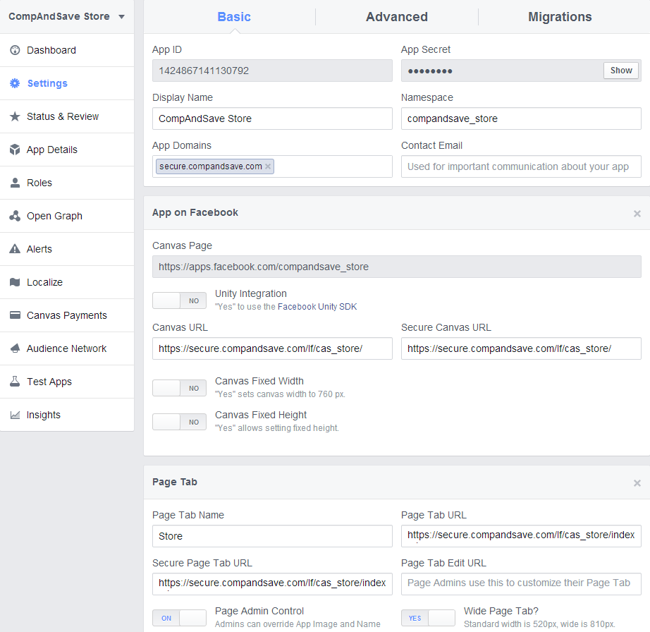

- Write php code for this store front app
Put this js in your code, it will link to the fb app you create, “appId” is your fb app id you create before.

<script>
window.fbAsyncInit = function() {
FB.init({
"appId": "622987527797454",
"status": true,
"cookie": true,
"xfbml": true
});
};

(function(d, s, id) {
var js, fjs = d.getElementsByTagName(s)[0];
if (d.getElementById(id)) return;
js = d.createElement(s); js.id = id;
js.src = "//connect.facebook.net/en_US/all.js";
fjs.parentNode.insertBefore(js, fjs);
}(document, 'script', 'facebook-jssdk'));
</script>

- Add the app to a Facebook page

https://www.facebook.com/dialog/pagetab?app_id=622987527797454&redirect_uri=https://secure.compandsave.com/lf/cas_store/index.php

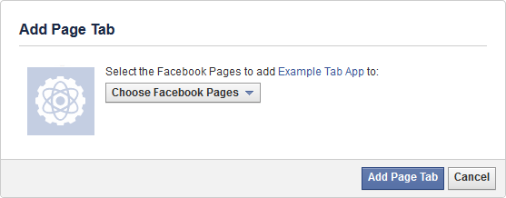

Now you create the fb store app on the face book page.

